**Semester Two**

**Examination 2020**

**Question/Answer booklet**

**MATHEMATICS**

**SPECIALIST UNITS 3 & 4**

**Section Two:**

**Calculator-assumed**

|  |
| --- |
| Student Name: _____________________________________ |
| Teacher’s Name: _____________________________________ |

**Time allowed for this section**

Reading time before commencing work: ten minutes

Working time for paper: one hundred minutes

**Material required/recommended for this section**

**To be provided by the supervisor**

This Question/Answer booklet

Formula Sheet (retained from Section One)

**To be provided by the candidate**

Standard items: pens (blue/black preferred), pencils (including coloured), sharpener, correction tape/fluid, erasers, ruler, highlighters

Special Items: drawing instruments, templates, notes on two unfolded sheets of A4 paper, and up to three calculators approved for use in the WACE examinations.

**Important note to candidates**

No other items may be taken into the examination room. It is **your** responsibility to ensure that you do not have any unauthorised notes or other items of a non-personal nature in the examination room. If you have any unauthorised material with you, hand it to the supervisor **before** reading any further.

**Structure of this paper**

|  |  |  |  |  |  |
| --- | --- | --- | --- | --- | --- |
|  | Number of questions available | Number of questions to be attempted | Working time (minutes) | Marks available | Percentage of exam |
| **Section One**  **Calculator—free** | **8** | **8** | **50** | **53** | **35** |
| Section Two  Calculator—assumed | 12 | 12 | 100 | 97 | 65 |
|  | | | |  | 100 |

**Instructions to candidates**

1. The rules for the conduct of Western Australian external examinations are detailed in the

*Year 12 Information Handbook 2020.* Sitting this examination implies that you agree to abide by these rules.

1. Answer the questions according to the following instructions.

**Show all your working clearly.** Your working should be in sufficient detail to allow your

answers to be checked readily and for marks to be awarded for reasoning. Incorrect answers given without supporting reasoning cannot be allocated any marks. For any question or part question worth more than two marks, valid working or justification is required to receive full marks. If you repeat an answer to any question, ensure that you cancel the answer you do not wish to have marked.

It is recommended that you **do not use pencil**, except in diagrams.

1. You must be careful to confine your responses to the specific questions asked and to follow any instructions that are specific to a particular question.
2. Spare pages are included at the end of this booklet. They can be used for planning your responses and/or as additional space if required to continue an answer.

* Planning: If you use the spare pages for planning, indicate this clearly at the top of the page.
* Continuing an answer: If you need to use the space to continue an answer, indicate in the original answer space where the answer is continued, i.e. give the page number. Fill in the number of the question that you are continuing to answer at the top of the page.

1. The Formula Sheet is **not** handed in with your Question/Answer Booklet.

# Section Two: Calculator–assumed 65% (97 marks)

This section has **twelve (12)** questions. Attempt **all** questions. Write your answers in the spaces

provided.

Working time: 100 minutes

**Question 9 (5 marks)**

The diagram shows the locus of all points that satisfy the conditions $\left|z\right|=1$ and $0<\arg\left(z\right)≤π$.

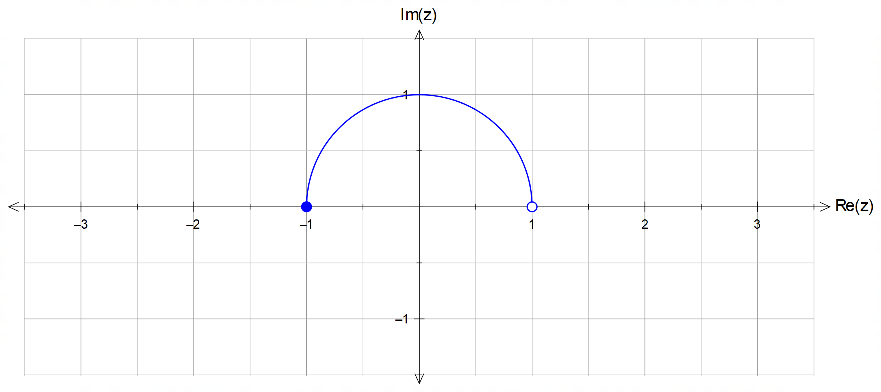

(a) Sketch on the same axes the locus of all points defined by $\left|z-2\right|=1$ and

$0<\arg\left(z-2\right)≤π$. [Hint: consider $w=z-2$] (3 marks)

(b) Determine the maximum value of $\arg\left(z-2\right)$ for your answer in (a), and the

exact value of $\left|z-2\right|$ at this point. (2 marks)

**Question 10 (7 marks)**

The slope field shown below is given by $\frac{dy}{dx}=y\sin{x}$.

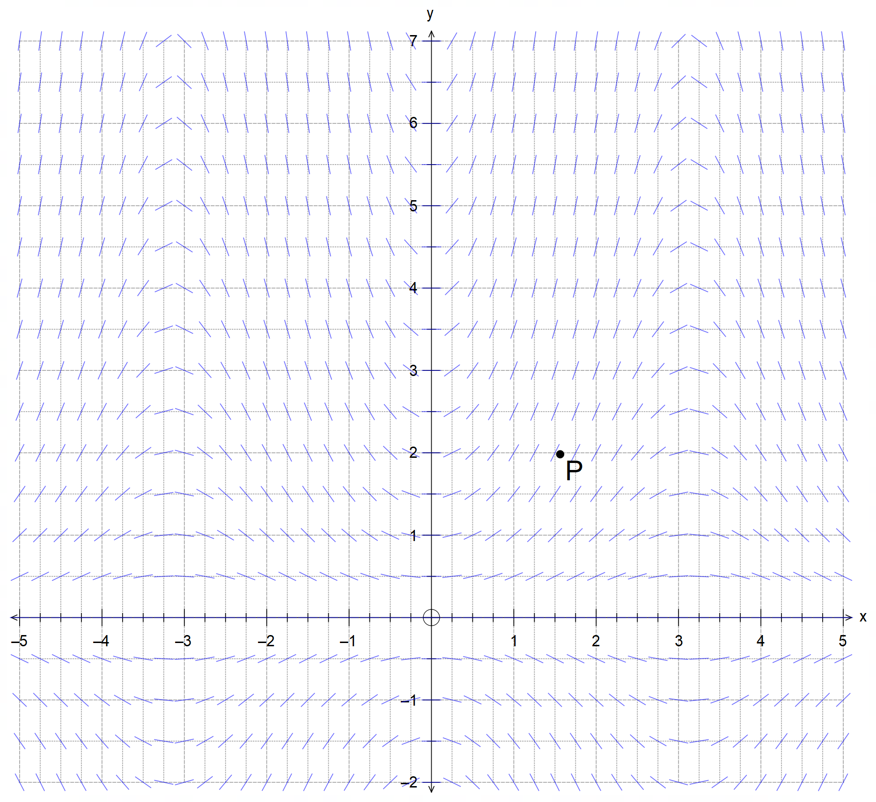

(a) Determine the value of the slope field at the point $P\left(\frac{π}{2}, 2\right)$ shown. (1 mark)

(b) Sketch the solution to the differential equation at the point $P\left(\frac{π}{2}, 2\right)$. (2 marks)

**(Question 10 – Continued)**

(c) Determine the equation of the solution to the differential equation at $P\left(\frac{π}{2}, 2\right)$. (4 marks)

**Question 11 (13 marks)**

(a) (i) Solve the equation $z^{4}+1=0$, writing all solutions in the format $z=r\operatorname{cis}{θ}$,

where $r>0$ and $-π<θ≤π$. (4 marks)

(ii) Hence, sketch on the Argand plane below the solutions to ${\left(z-2i\right)}^{4}+1=0$.

[Hint: Consider $w=z-2i$ and your answer in (a)] (3 marks)

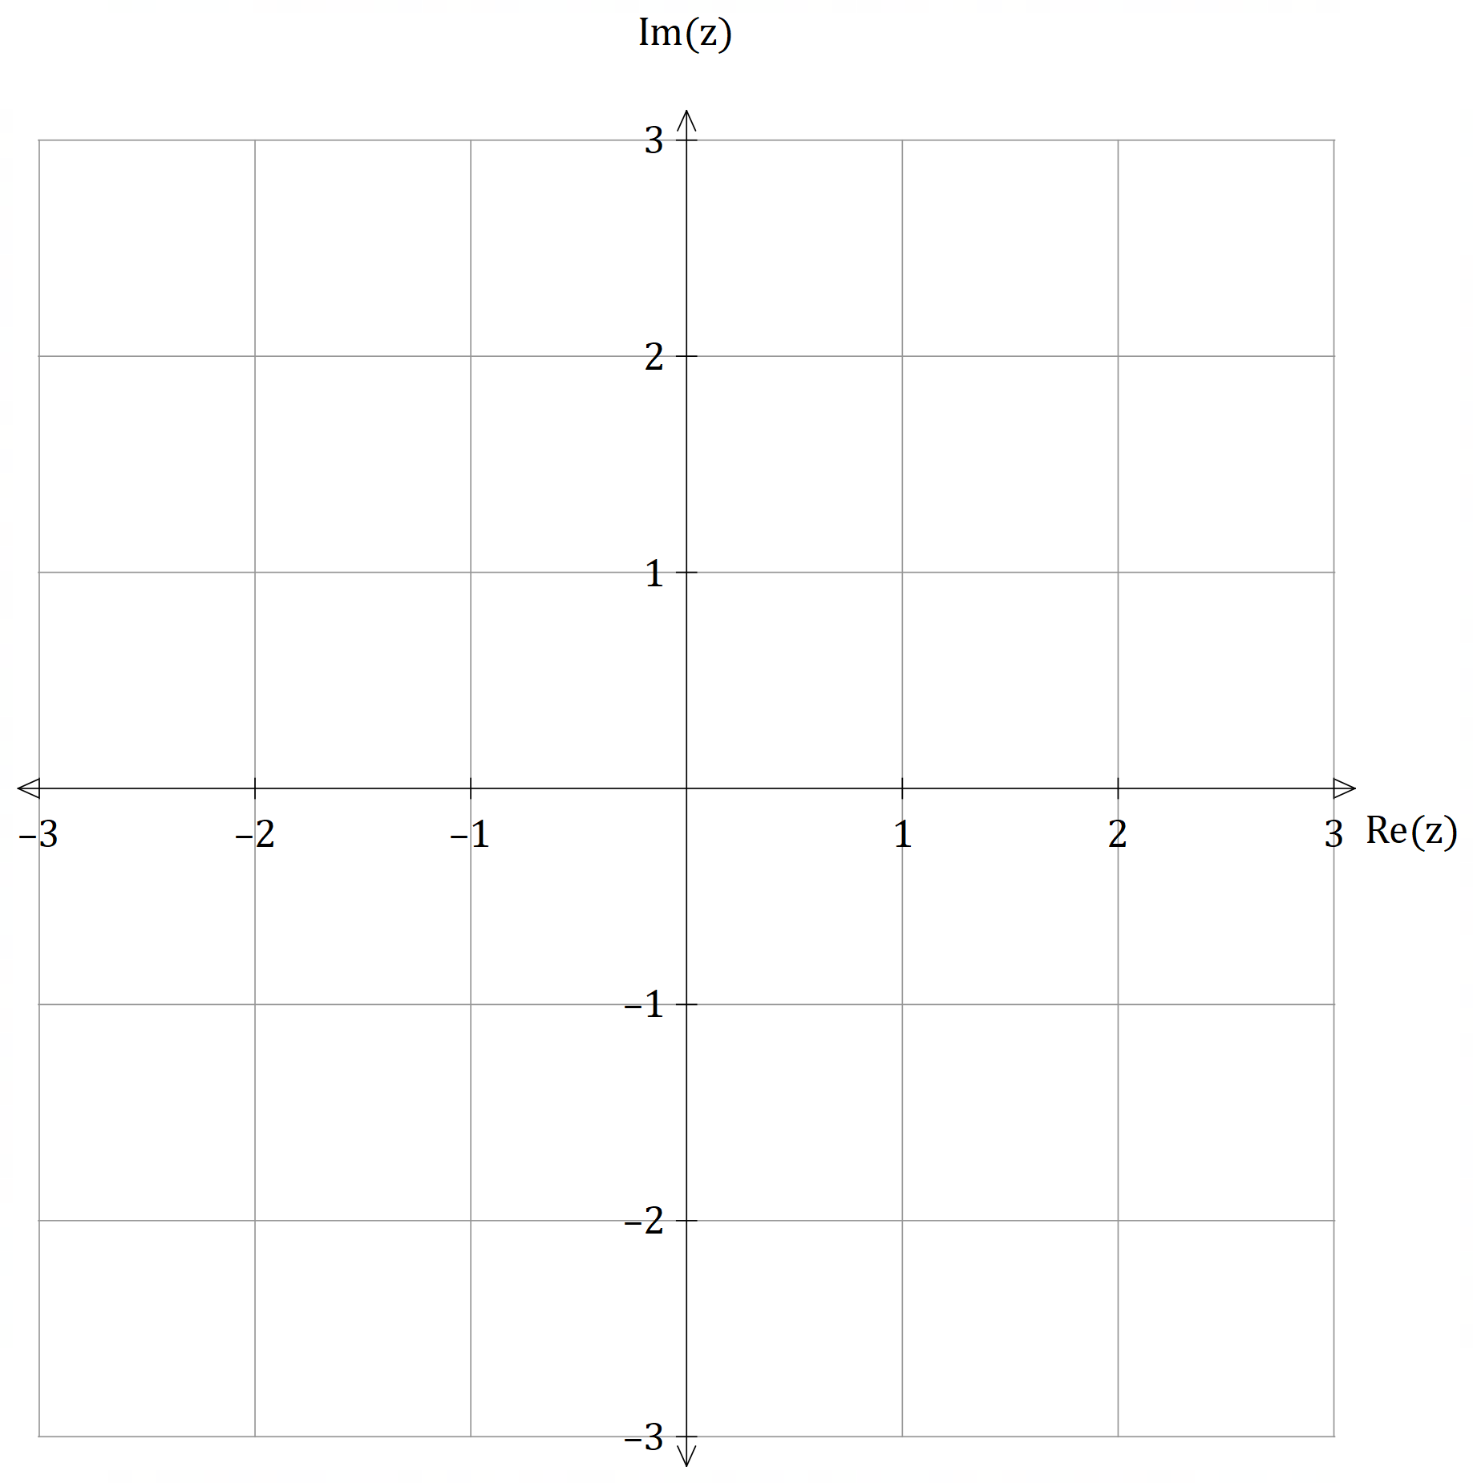

**(Question 11 – Continued)**

(b) (i) Determine $Re\left(z\right)$ and $Im\left(z\right)$ for $z=\frac{\sqrt{3} + i}{1 - i}$. (2 marks)

(ii) Write $z=\frac{\sqrt{3} + i}{1 - i}$ in polar format $z=r\operatorname{cis}{θ}$, and hence, show that:

$\cos\left(\frac{5π}{12}\right)=\frac{\sqrt{2}}{4}\left(\sqrt{3}-1\right)$ (4 marks)

**Question 12 (12 marks)**

At $t=0$ a particle P begins its motion from $2i+j$ metres, moving with velocity $v\left(t\right)$ in metres/second for $t$ seconds, where $v\left(t\right)=\left(2t\right)i+\left(\sin{t}\right)j$. The path traced by the particle is shown on the axes below, where the point $M\left(a, b\right)$ is the global maximum with $a, b∈R$.

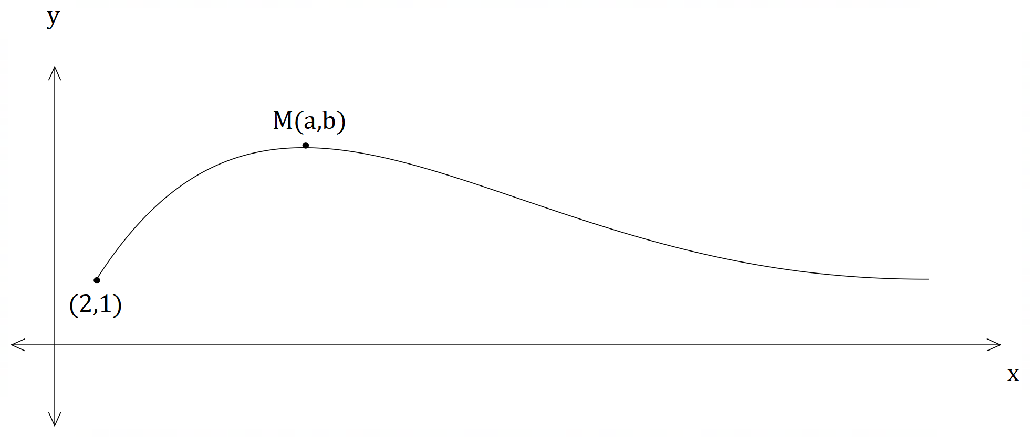

(a) Find the position vector $r\left(t\right)$ of the particle for any time $t$. (3 marks)

**(Question 12 – Continued)**

(b) Determine the magnitude of the acceleration $a\left(t\right)$ of the particle when the motion began.

(3 marks)

(c) State the exact value of the constants $a$ and $b$. Justify your answers. (3 marks)

$$L=\int_{c}^{d}{s\left(t\right)dt}$$

The distance $L$ travelled by the particle for the interval $c≤t≤d$ is given by ,

where $s\left(t\right)$ is the speed of the object at time $t$.

(d) Set up an integral to determine the distance travelled by the particle in the

first 10 seconds, and then use your CAS calculator to determine this distance

correct to **two (2)** decimal places.

(3 marks)

**Question 13 (10 marks)**

The emergency room (ER) at a major hospital monitors the temperature of all incoming patients to check for fever. The temperature $T$ of each patient is recorded as they come into the ER.

The known parameters for the temperature of the population are $μ\left(T\right)=37°C$ and $σ\left(T\right)=0.25°C$.

A sample of 100 incoming patients is taken for analysis.

(a) State the (approximate) distribution of the sample mean temperature for the 100 patients.

(3 marks)

(b) What is the probability that the sample mean temperature will be more than $37.005°C$?

(2 marks)

**(Question 13 – Continued)**

Suppose that more than 100 patients’ temperature were considered for the analysis.

(c) How would this affect your answer to part (b)? Explain your recalculation. (2 marks)

It is desired that the probability that the sample mean temperature will range between $37°C$ and $37.005°C$ is greater than $45\%$.

(d) Determine the minimum number of patients that will need to be tested. (3 marks)

**Question 14 (8 marks)**

Two radio-controlled drones take off at the same time from two different positions and with constant velocities. From an observer at O, drone A leaves from the point with position vector $20i-10j$ m and has a velocity of $-2i+j+3k$ m/s; drone B leaves from the point with position vector $-10i+30j$ m and has a velocity of $xi+yj+zk$ m/s.

(a) Find the distance between the drones after 2 seconds of flight given that drone B has

a velocity of $3i-2j+4k$ m/s. (4 marks)

(b) Determine the velocity of drone B given that they collide at $30k$ m from O. (4 marks)

**Question 15 (6 marks)**

Determine the exact length of the section of the line $r=\left(4-2λ\right)i+\left(2+λ\right)j+\left(3+λ\right)k$ that lies in the first octant. Show working to justify your answer.

(6 marks)

**Question 16 (8 marks)**

After some research into the population of wild cats in outback WA, it was found that the population $P$ can be modelled by:

$$P\left(t\right)=\frac{80 000}{5+3e^{-0.25t}}$$

where $t$ is the time in years from today.

(a) What is the population today? (1 mark)

(b) What does the model predict that the eventual population will be? (1 mark)

**(Question 16 – Continued)**

$$\frac{dP}{dt}=\frac{P}{4}\left(1-\frac{P}{16 000}\right)$$

(c) Show that $P$ satisfies the differential equation:

(4 marks)

(d) What is the instantaneous annual rate of growth today? (2 marks)

**Question 17 (9 marks)**

Perth Airport keeps records of the on-time departure and delays of all flights and these are published at the end of each month.

For the month of July in 2019, a sample of $n$ flights showed that the average departure delay time was $20$ minutes. Repeated sampling of the mean showed that the standard deviation of the sample means was $2$ minutes.

(a) Determine a $90\%$ confidence interval for the population mean departure-delay time $μ$,

correct to $0.01$ minutes. (3 marks)

A second random sample of $2n$ flights in August 2019 found that the average departure delay time was $22$ minutes. Assume that both the July and August samples were taken from the same population.

(b) What is the standard deviation of the sample means for the August sample, correct to

$0.01$ minutes? (2 marks)

**(Question 17 – Continued)**

A student wishes to combine the July and August samples to form a larger sample of size $3n$.

He will consider a $90\%$ confidence interval for the following samples in order to obtain the population mean for the departure delay time $μ$.

|  |  |  |
| --- | --- | --- |
| 90% Confidence Interval | Sample | Size |
| J | July | $$n$$ |
| A | August | $$2n$$ |
| C | Combined | $$3n$$ |

(c) Which of the three confidence intervals (J, A or C) will provide the most accurate value in

determining the population mean $μ$? Justify your answer. (2 marks)

(d) Which of the three confidence intervals (J, A or C) contains the true value of the population

mean $μ$? Justify your answer. (2 marks)

**Question 18 (7 marks)**

The rotating component of an industrial machine undergoes simple harmonic motion that can be described by the differential equation $\frac{d^{2}x}{dt^{2}}=-9x$, where $x$ is its displacement from the mean position

at $t$ seconds.

(a) State the period $T$ of the motion. (2 marks)

(b) If the maximum speed of the component is $1.5$ m/s, then find the amplitude of the motion.

(2 marks)

**(Question 18 – Continued)**

(c) The amplitude and period of the same component in a newer machine are now changed.

Readings of its motion are taken and it is found that when $x=\sqrt{3}$ m, the speed is $6$ m/s, and

when $x=\sqrt{2}$ m, the speed of the component is $6\sqrt{2}$ m/s.

Find the new exact values for: (3 marks)

(i) the period.

(ii) the amplitude.

**Question 19(7 marks)**

Consider the sphere of radius $r$ centred at the origin.

A vertical slice of the sphere is taken for $x=a$ and $x=b$ where $-r≤a<b≤r$, as shown.

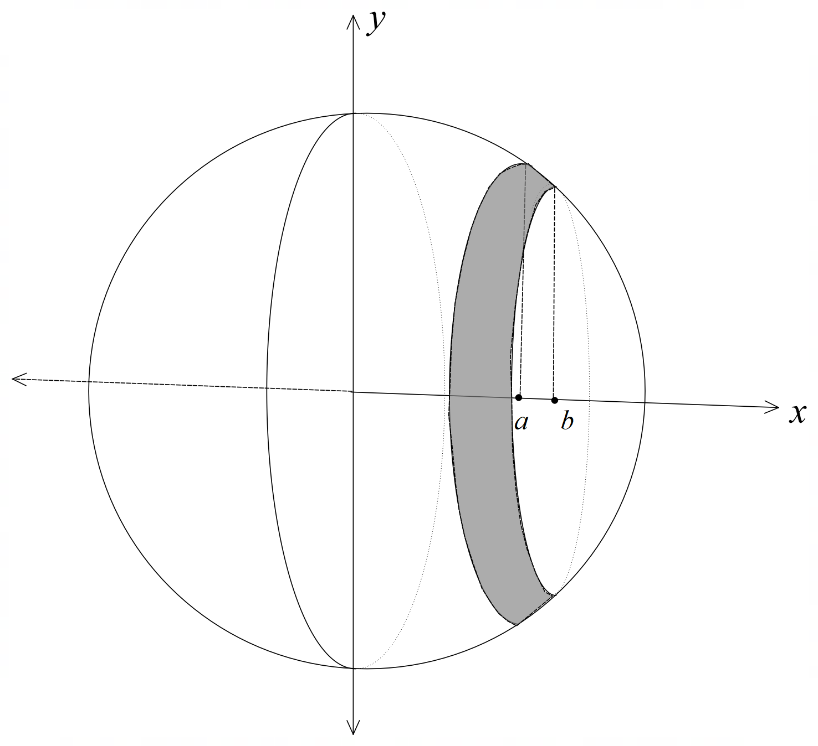

$$A=\int_{a}^{b}{2πy\sqrt{1+{\left(\frac{dy}{dx}\right)}^{2}}}dx$$

It can be shown that the surface area of the slice is given by .

(a) Set up the integral that gives the area of the slice in terms of $x$ and $y$. (3 marks)

**(Question 19 – Continued)**

(b) Simplify your integral in (a) to leave it in terms of $x$ only, and then show that the area

of the slice is given by $A=2πr\left(b-a\right)$. (3 marks)

(c) Hence, show that the surface area of the sphere is given by $A=4πr^{2}$. (1 mark)

**Question 20 (5 marks)**

The position vector of a moving particle is given by $r\left(t\right)=\left(\begin{matrix}x\left(t\right) \\ y\left(t\right) \\ z\left(t\right)\end{matrix}\right)$,

where $t$ is the time since the motion begins.

Use vector calculus and implicit differentiation to show that if the particle moves with constant

speed, then its velocity and acceleration vectors are perpendicular at any point on its trajectory.

(5 marks)

**End of questions**

**Additional working space**

Question number(s): ……………………

**Additional working space**

Question number(s): ……………………